

LAB REPORT

ARTIFICIAL INTELLIGENCE

SUBMITTED BY:

MIRZA FERAZ HUSSAN

CSU-S15-113

BSCS(7)

**SUBMITTED TO:**

SIR USMAN

TOWER OF HANOI PROBLEM

**CODE:**

#include<stdio.h>

void towers(int num,char frompeg, char topeg, char auxpeg)

{

if (num==1)

{

printf("\n move disk 1 frompeg %c topeg %c", frompeg,topeg);

return;

}

towers(num-1 ,frompeg, auxpeg, topeg);

printf("\n move disk %d frompeg %c topeg %c",num,frompeg,topeg);

towers(num-1,auxpeg,topeg,frompeg);

}

int main()

{

int num;

printf("Enter the number of disks : ");

scanf("%d",&num);

printf("The sequence of moves involved in the tower of Hanoi are :\n");

towers(num,'A','c','B');

return 0;

}

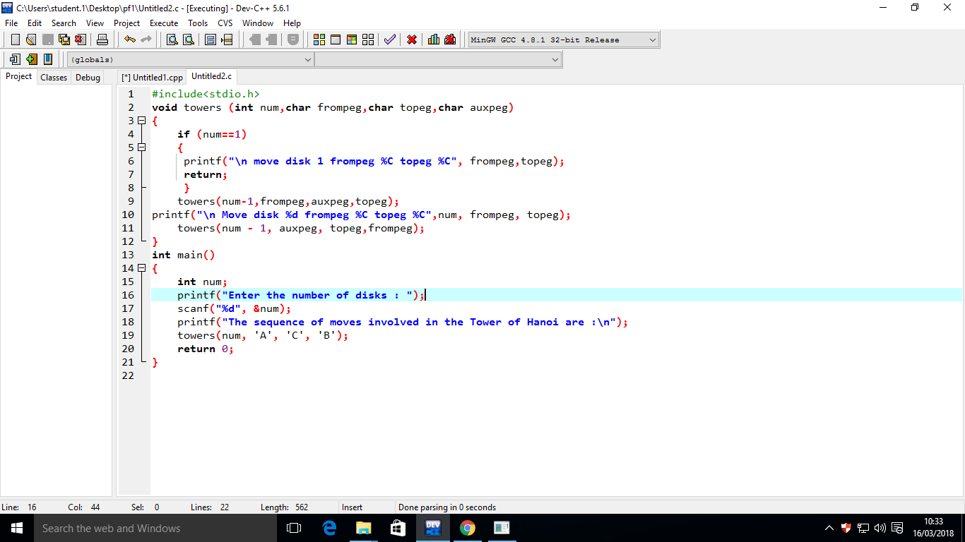

**When Run the Code:**

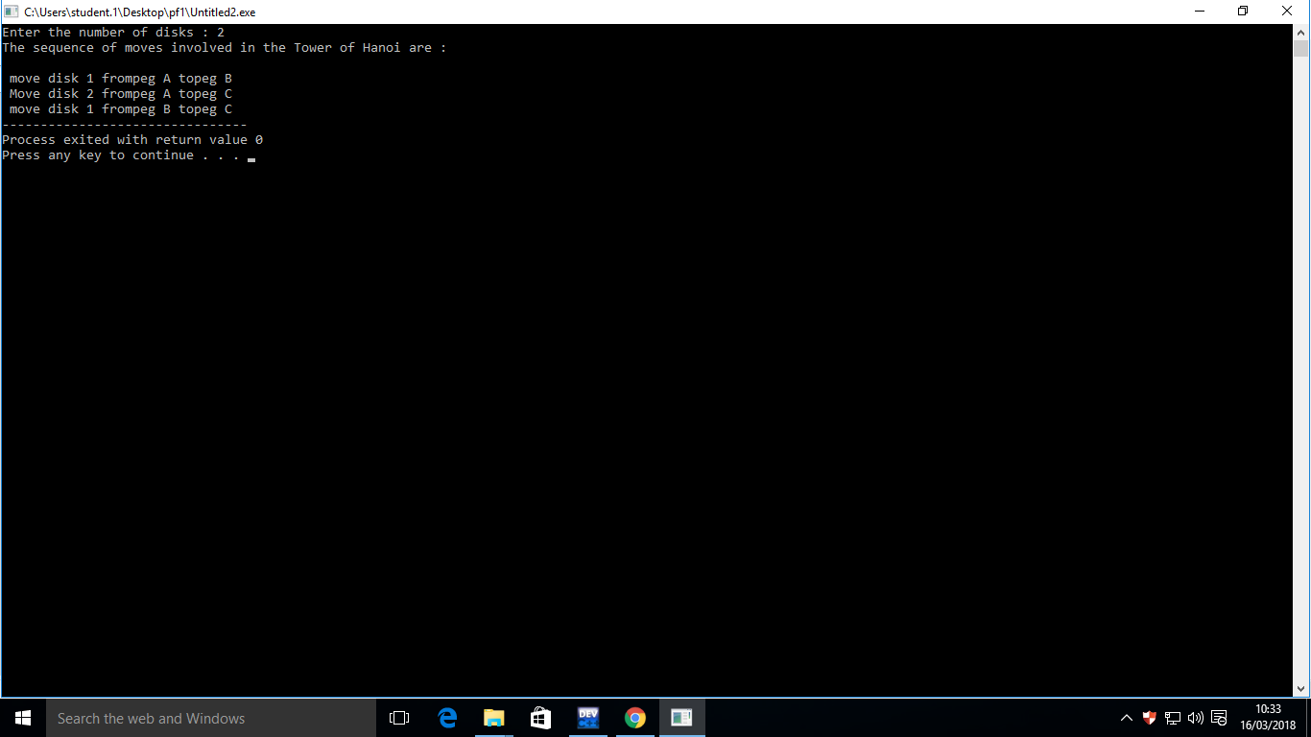

**Disk :2**

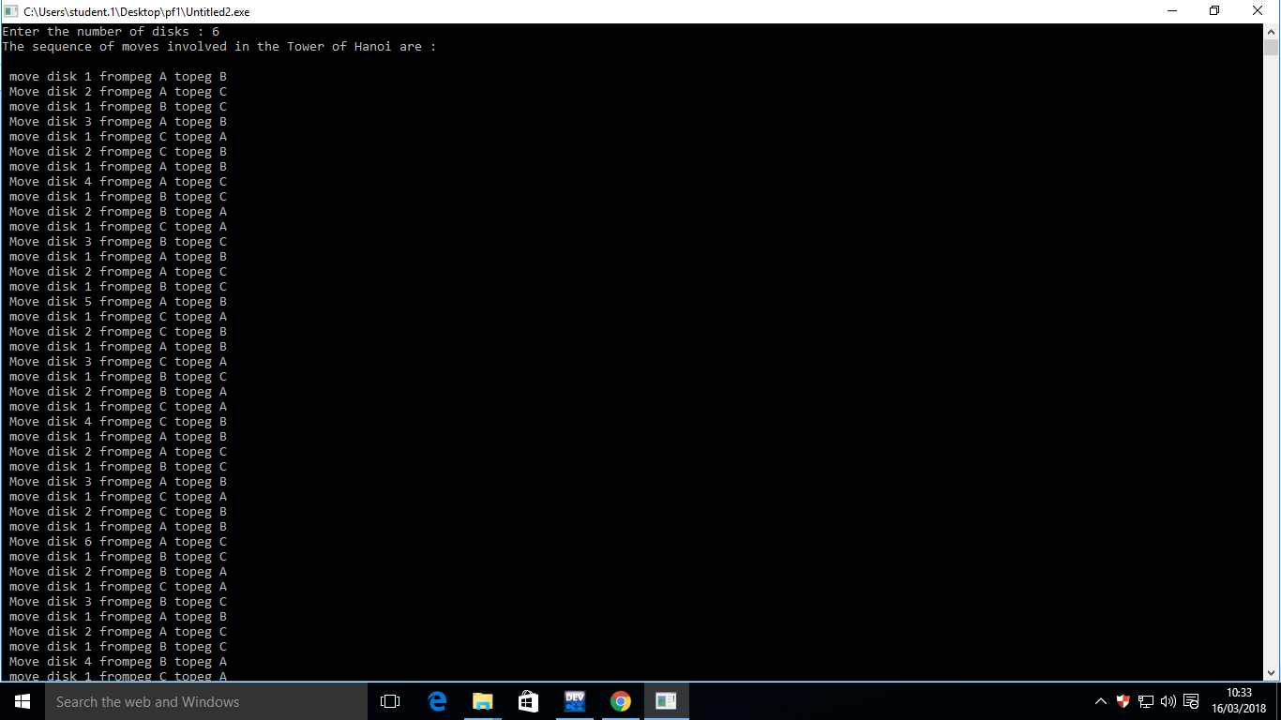

**Disks: 6**

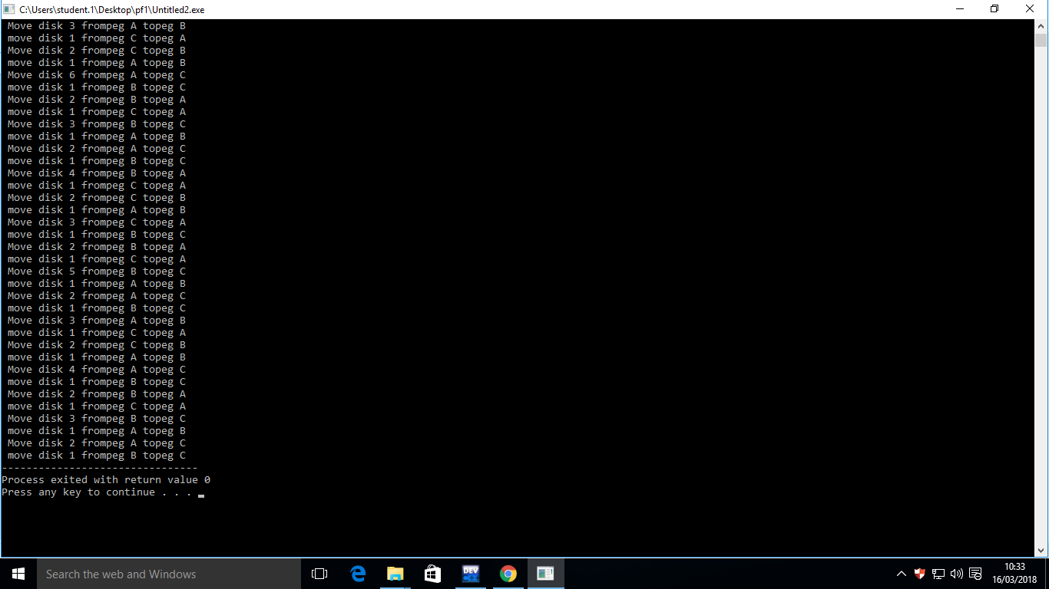

**Disks: 6**